Answer the following questions:

1. What does it mean to say that data is 'persistent'?

**Answer**

|  |
| --- |
| **It is a data type that stays in the same place and doesn’t change.** |

2. What's the difference, in terms of *where* data is located, for data stored in a global variable vs. data stored in a database?

**Answer**

|  |
| --- |
| **Data stored globally can be acssesed from anything. Things stored in a database can only be pulled through that database.** |

3. Include screenshots and explanations of your enhancements.

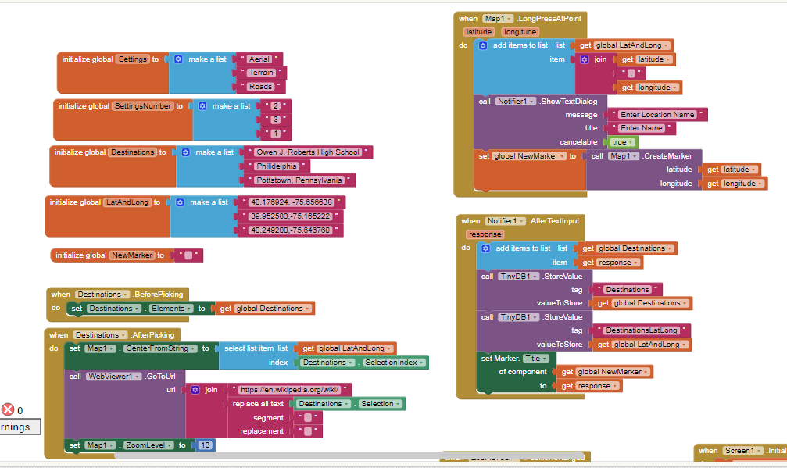This palce the marker and then creates a new destination.

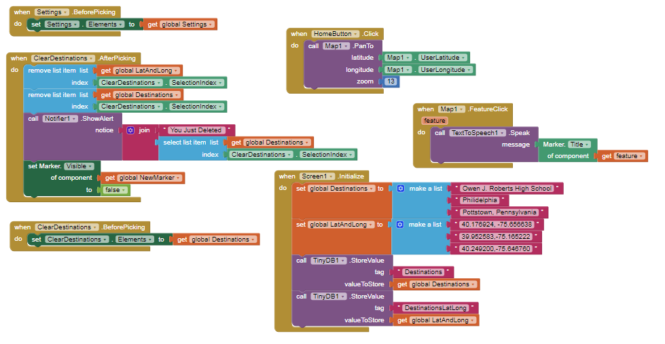

This saves the destomations. Does text to speach and clears destinations.